Design Patterns and Principles (Mandatory hands-on)

Exercise 1: Implementing the Singleton Pattern
Logger.cs
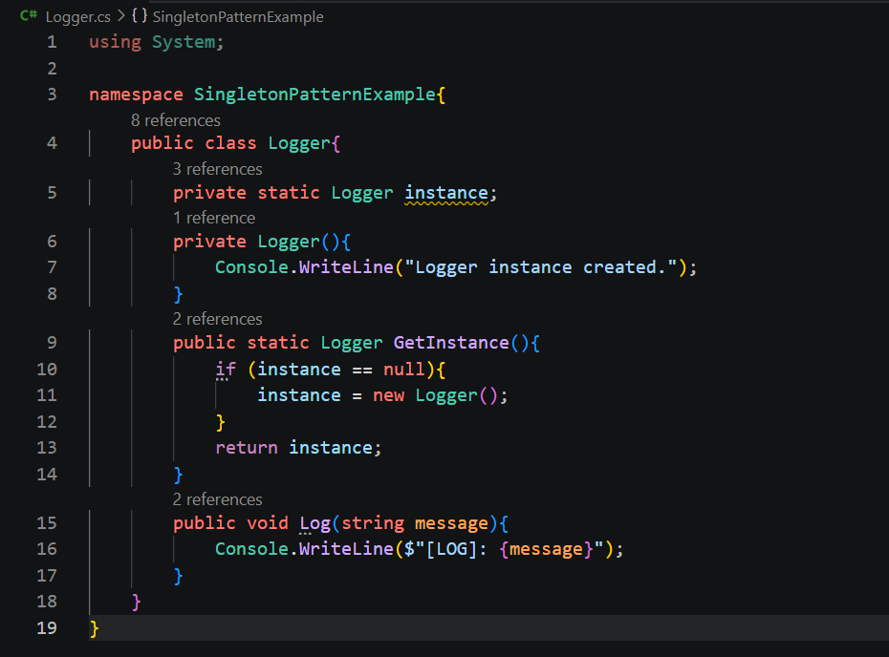
Program.cs
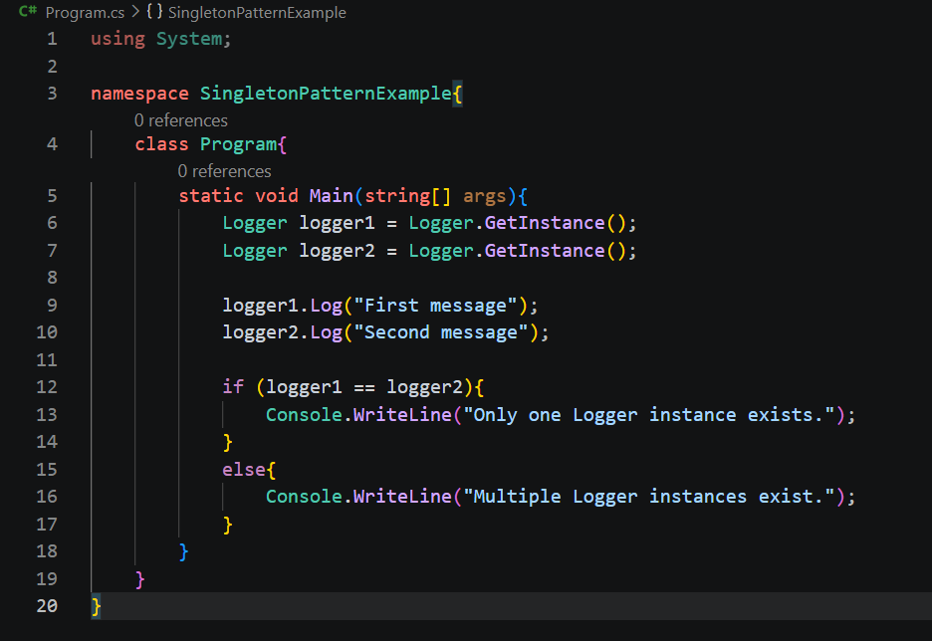
Output:
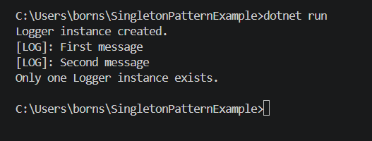

Exercise 2: Implementing the Factory Method Pattern
DocumentFactory.cs

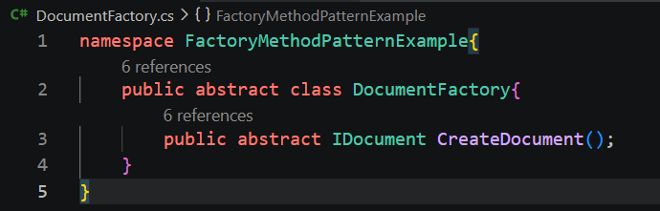

ExcelDocument.cs

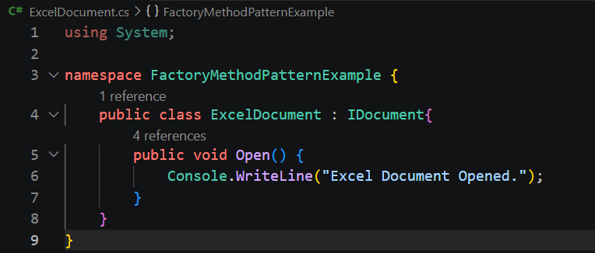

ExcelDocumentFactory.cs
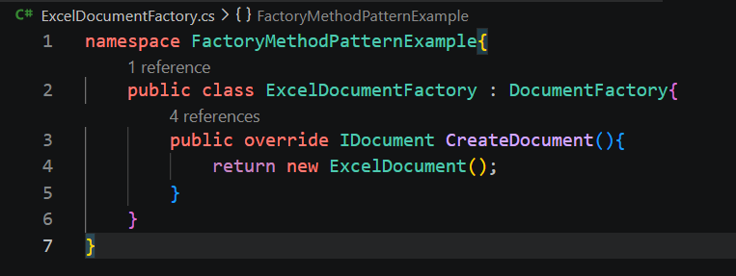
IDocument.cs

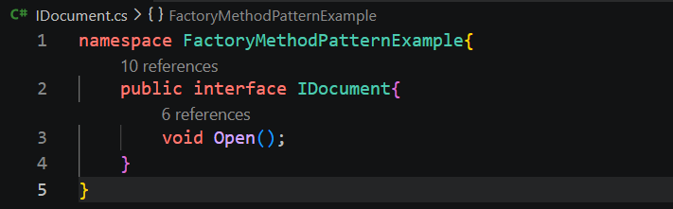

PdfDocument.cs

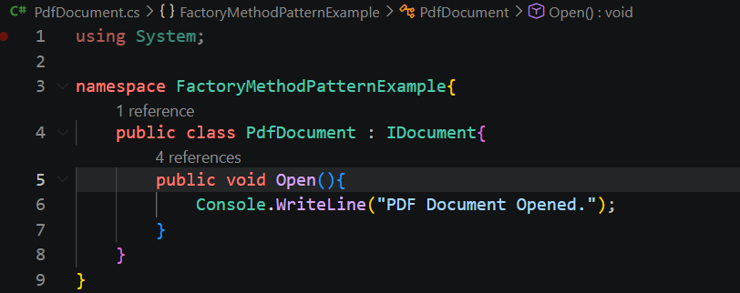

PdfDocumentFactory.cs

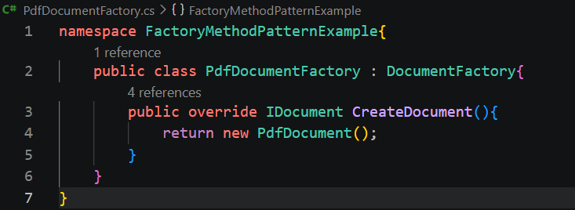

WordDocument.cs

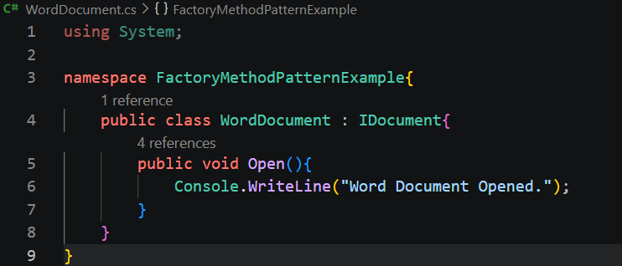
WordDocumentFactory.cs

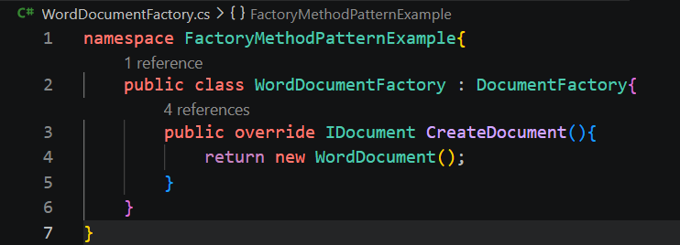

Program.cs

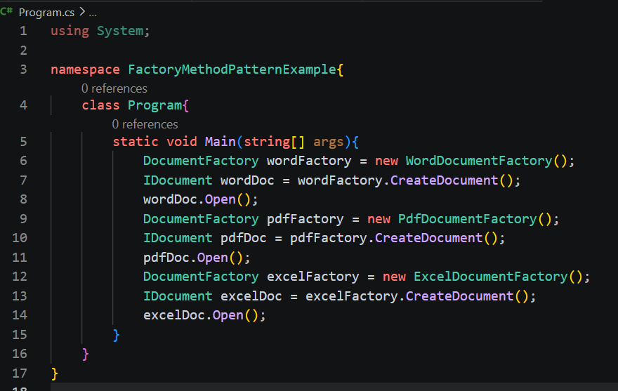

Output :

